Exercício 5

Gustavo Beretta Gonçalves

if (!require("forecast")) install.packages("forecast", dependencies=TRUE)

## Carregando pacotes exigidos: forecast

## Warning: package 'forecast' was built under R version 4.3.3

## Registered S3 method overwritten by 'quantmod':  
## method from  
## as.zoo.data.frame zoo

library(forecast)  
library(zoo)

##   
## Attaching package: 'zoo'

## The following objects are masked from 'package:base':  
##   
## as.Date, as.Date.numeric

ipca_data <- read.csv2("ipca.csv")  
ipca_data <- ts(ipca_data$IPCA, start = c(1994, 8), frequency = 12)  
  
#a)  
ses_model <- ses(ipca_data)  
summary(ses_model)

##   
## Forecast method: Simple exponential smoothing  
##   
## Model Information:  
## Simple exponential smoothing   
##   
## Call:  
## ses(y = ipca_data)   
##   
## Smoothing parameters:  
## alpha = 0.7307   
##   
## Initial states:  
## l = 1.8482   
##   
## sigma: 0.3639  
##   
## AIC AICc BIC   
## 1346.654 1346.724 1358.228   
##   
## Error measures:  
## ME RMSE MAE MPE MAPE MASE ACF1  
## Training set -0.006279753 0.362857 0.2606874 -Inf Inf 0.6587839 0.05951103  
##   
## Forecasts:  
## Point Forecast Lo 80 Hi 80 Lo 95 Hi 95  
## Oct 2023 0.2422466 -0.2241078 0.7086009 -0.4709809 0.955474  
## Nov 2023 0.2422466 -0.3353332 0.8198264 -0.6410855 1.125579  
## Dec 2023 0.2422466 -0.4283580 0.9128511 -0.7833546 1.267848  
## Jan 2024 0.2422466 -0.5099652 0.9944583 -0.9081620 1.392655  
## Feb 2024 0.2422466 -0.5835467 1.0680398 -1.0206952 1.505188  
## Mar 2024 0.2422466 -0.6510879 1.1355811 -1.1239907 1.608484  
## Apr 2024 0.2422466 -0.7138698 1.1983630 -1.2200073 1.704500  
## May 2024 0.2422466 -0.7727759 1.2572690 -1.3100963 1.794589  
## Jun 2024 0.2422466 -0.8284460 1.3129392 -1.3952365 1.879730  
## Jul 2024 0.2422466 -0.8813613 1.3658545 -1.4761634 1.960657

autoplot(ses_model)

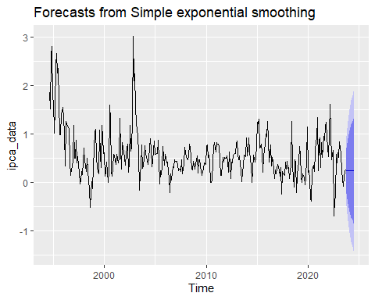

#b)  
holt_model <- holt(ipca_data)  
summary(holt_model)

##   
## Forecast method: Holt's method  
##   
## Model Information:  
## Holt's method   
##   
## Call:  
## holt(y = ipca_data)   
##   
## Smoothing parameters:  
## alpha = 0.7274   
## beta = 1e-04   
##   
## Initial states:  
## l = 1.8382   
## b = -0.0046   
##   
## sigma: 0.3649  
##   
## AIC AICc BIC   
## 1350.600 1350.774 1369.890   
##   
## Error measures:  
## ME RMSE MAE MPE MAPE MASE ACF1  
## Training set 0.000125196 0.362829 0.2608868 -Inf Inf 0.6592877 0.06208698  
##   
## Forecasts:  
## Point Forecast Lo 80 Hi 80 Lo 95 Hi 95  
## Oct 2023 0.2356095 -0.2320545 0.7032736 -0.4796210 0.950840  
## Nov 2023 0.2310184 -0.3473061 0.8093429 -0.6534526 1.115489  
## Dec 2023 0.2264272 -0.4445725 0.8974269 -0.7997783 1.252633  
## Jan 2024 0.2218360 -0.5305294 0.9742015 -0.9288076 1.372480  
## Feb 2024 0.2172448 -0.6085268 1.0430165 -1.0456639 1.480154  
## Mar 2024 0.2126537 -0.6805292 1.1058365 -1.1533516 1.578659  
## Apr 2024 0.2080625 -0.7478058 1.1639308 -1.2538120 1.669937  
## May 2024 0.2034713 -0.8112330 1.2181756 -1.3483850 1.755328  
## Jun 2024 0.1988802 -0.8714456 1.2692059 -1.4380418 1.835802  
## Jul 2024 0.1942890 -0.9289214 1.3174993 -1.5235130 1.912091

autoplot(holt_model)

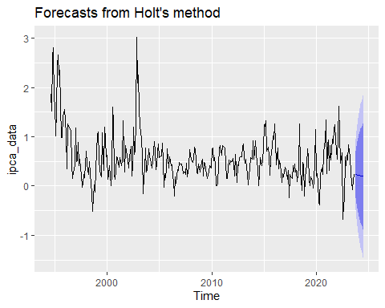

#c)  
hw_model <- hw(ipca_data)  
summary(hw_model)

##   
## Forecast method: Holt-Winters' additive method  
##   
## Model Information:  
## Holt-Winters' additive method   
##   
## Call:  
## hw(y = ipca_data)   
##   
## Smoothing parameters:  
## alpha = 0.7023   
## beta = 1e-04   
## gamma = 1e-04   
##   
## Initial states:  
## l = 2.1001   
## b = -0.0064   
## s = -0.0532 -0.1536 -0.0455 0.0676 0.0727 0.0996  
## 0.1746 0.1444 0.0916 0.0387 -0.2073 -0.2295  
##   
## sigma: 0.354  
##   
## AIC AICc BIC   
## 1340.963 1342.807 1406.548   
##   
## Error measures:  
## ME RMSE MAE MPE MAPE MASE ACF1  
## Training set 0.002361196 0.3458065 0.249496 -Inf Inf 0.630502 0.06372361  
##   
## Forecasts:  
## Point Forecast Lo 80 Hi 80 Lo 95 Hi 95  
## Oct 2023 0.46894465 0.01528520 0.9226041 -0.2248676 1.162757  
## Nov 2023 0.51558372 -0.03881522 1.0699827 -0.3322963 1.363464  
## Dec 2023 0.56218758 -0.07729541 1.2016706 -0.4158173 1.540192  
## Jan 2024 0.58603374 -0.12849257 1.3005600 -0.5067399 1.678807  
## Feb 2024 0.50480293 -0.27762036 1.2872262 -0.6918102 1.701416  
## Mar 2024 0.47159233 -0.37330625 1.3164909 -0.8205685 1.763753  
## Apr 2024 0.46029894 -0.44277916 1.3633770 -0.9208398 1.841438  
## May 2024 0.34088444 -0.61686058 1.2986295 -1.1238602 1.805629  
## Jun 2024 0.22657535 -0.78289484 1.2360455 -1.3172761 1.770427  
## Jul 2024 0.32069807 -0.73798680 1.3793829 -1.2984207 1.939817  
## Aug 2024 0.13811387 -0.96761045 1.2438382 -1.5529455 1.829173  
## Sep 2024 0.15404872 -0.99680660 1.3049040 -1.6060326 1.914130  
## Oct 2024 0.39368548 -0.80062101 1.5879920 -1.4328487 2.220220  
## Nov 2024 0.44032455 -0.79590675 1.6765559 -1.4503281 2.330977  
## Dec 2024 0.48692841 -0.78986316 1.7637200 -1.4657558 2.439613  
## Jan 2025 0.51077456 -0.80533892 1.8268880 -1.5020473 2.523596  
## Feb 2025 0.42954376 -0.92476114 1.7838487 -1.6416868 2.500774  
## Mar 2025 0.39633315 -0.99512575 1.7877921 -1.7317196 2.524386  
## Apr 2025 0.38503977 -1.04261675 1.8126963 -1.7983725 2.568452  
## May 2025 0.26562527 -1.19734344 1.7285940 -1.9717923 2.503043  
## Jun 2025 0.15131618 -1.34614196 1.6487743 -2.1388484 2.441481  
## Jul 2025 0.24543889 -1.28574149 1.7766193 -2.0962994 2.587177  
## Aug 2025 0.06285470 -1.50133039 1.6270398 -2.3293600 2.455069  
## Sep 2025 0.07878955 -1.51772720 1.6753063 -2.3628721 2.520451

autoplot(hw_model)

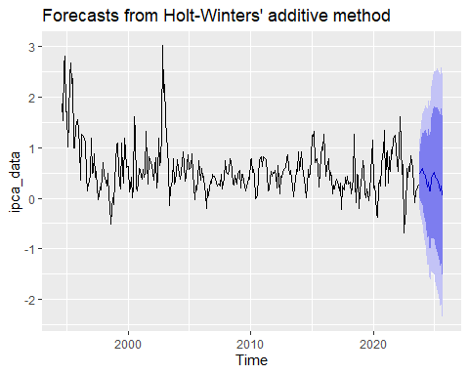

### d)

### 1. Simple Exponential Smoothing (SES)

* **AIC**: 1346.654
* **AICc**: 1346.724
* **BIC**: 1358.228
* **RMSE**: 0.362857
* **MAE**: 0.2606874
* **MAPE**: Inf
* **MASE**: 0.6587839

### 2. Holt's Linear Trend Method

* **AIC**: 1350.600
* **AICc**: 1350.774
* **BIC**: 1369.890
* **RMSE**: 0.362829
* **MAE**: 0.2608868
* **MAPE**: Inf
* **MASE**: 0.6592877

### 3. Holt-Winters' Additive Method

* **AIC**: 1340.963
* **AICc**: 1342.807
* **BIC**: 1406.548
* **RMSE**: 0.3458065
* **MAE**: 0.249496
* **MAPE**: Inf
* **MASE**: 0.630502

### Considerações

1. **Princípio da Parcimônia**:
   * O princípio da parcimônia (Occam's Razor) sugere que, entre modelos com desempenho similar, o mais simples deve ser preferido.
   * Dada a pequena diferença nos AIC/AICc entre SES e HW, SES é atraente por sua simplicidade.
2. **Erro de Previsão**:
   * A diferença nos RMSE e MAE indica que HW tem um desempenho um pouco melhor, mas a diferença não é substancial.
   * Se a precisão adicional oferecida pelo HW não justifica a complexidade adicional em termos de implementação, manutenção e interpretação, o SES pode ser preferido.

### Conclusão

Dada a análise, se a diferença nos indicadores de desempenho não justifica a maior complexidade do modelo HW, e se a simplicidade é um fator importante, o modelo SES deve ser priorizado. Este modelo oferece um bom equilíbrio entre desempenho e simplicidade, tornando-o uma escolha prática em muitas situações.

e)

• **Outubro de 2023**:

* Previsão pontual: **0.2422466**
* Intervalo de confiança de 80%: **[-0.2241078, 0.7086009]**
* Intervalo de confiança de 95%: **[-0.4709809, 0.955474]**

• **Novembro de 2023**:

* Previsão pontual: **0.2422466**
* Intervalo de confiança de 80%: **[-0.3353332, 0.8198264]**
* Intervalo de confiança de 95%: **[-0.6410855, 1.125579]**

• **Dezembro de 2023**:

* Previsão pontual: **0.2422466**
* Intervalo de confiança de 80%: **[-0.4283580, 0.9128511]**
* Intervalo de confiança de 95%: **[-0.7833546, 1.267848]**